Red black trees: binary trees that are ensured balance. Take O(log n) in worst case. || You can build a min/max heap in O(n) time. || Quick sort is worst when array is already sorted or reverse sorted. || Quick sort is not very efficient on small lists and is slow if there are many identical keys. || Quick sort is not stable. || Stable sorting algorithm: a sort in which equal items maintain the same relative order. || We can make quicksort run in Theta(n log n) using median finding. Can get ith largest element in theta(n) worst case using median. || Randomized quick sort is no different best/worse case than quicksort. ||
9. When you break a substring at the ith position, you add the length of the substring and the cost of breaking the two subproblems.
Then you have two subproblems: breaking the string from 0 to i and breaking the string from i to n. We consider as possible breakpoints all the values in the L set that have not been used so far.
When we are breaking the substring Si, Si+1, …, Sj we know the precomputed values of breaking such string at the breakpoints not used left (these are the subproblems, so if we apply bottom-up we know the smaller subproblem values). If we take the cut that has the optimal solution (optimal solution of the subproblem), then by adding the length of the string we will get the best optimal solution for the problem. If there is another subproblem with the best optimal solution, then by cut-and-paste we can get rid of our solution and get the solution using the best optimal solution of the subproblem, proving that we will get the best optimal solution.
(Kind of like the way he explains the best optimal substructure in the slides for the optima BST).

Insertion sort: Like one sorts cards. Consider looking through the cards one by one from left to right, and then any time you see something that should be lower you move all the cards up and put that card in the correct spot.
Merge sort: Recursive call to merge sort on two halves of the call, and at the end a call to merge which will actually do the work for us of combining sorts.

Asymptotic bounds refer to O, Omega, etc.
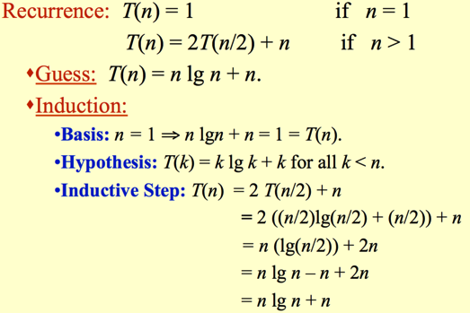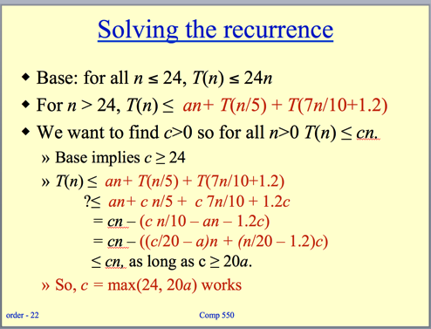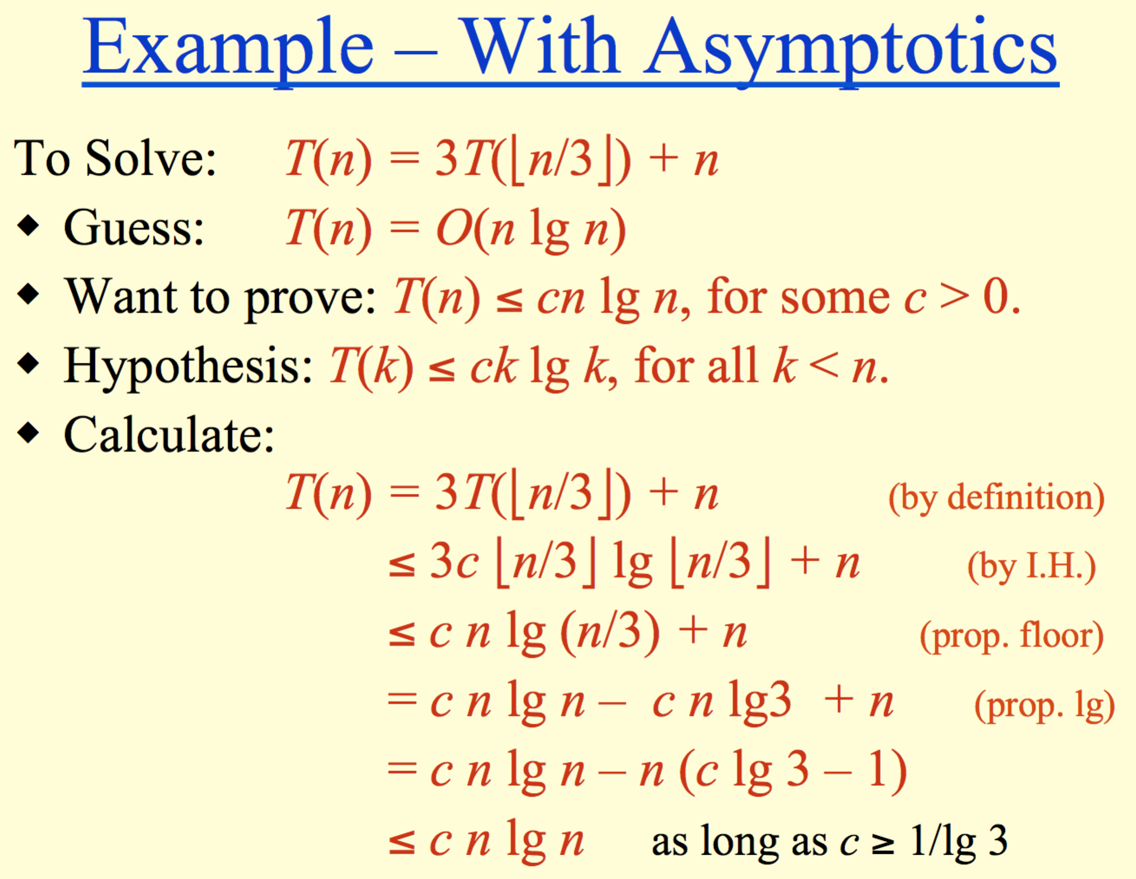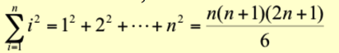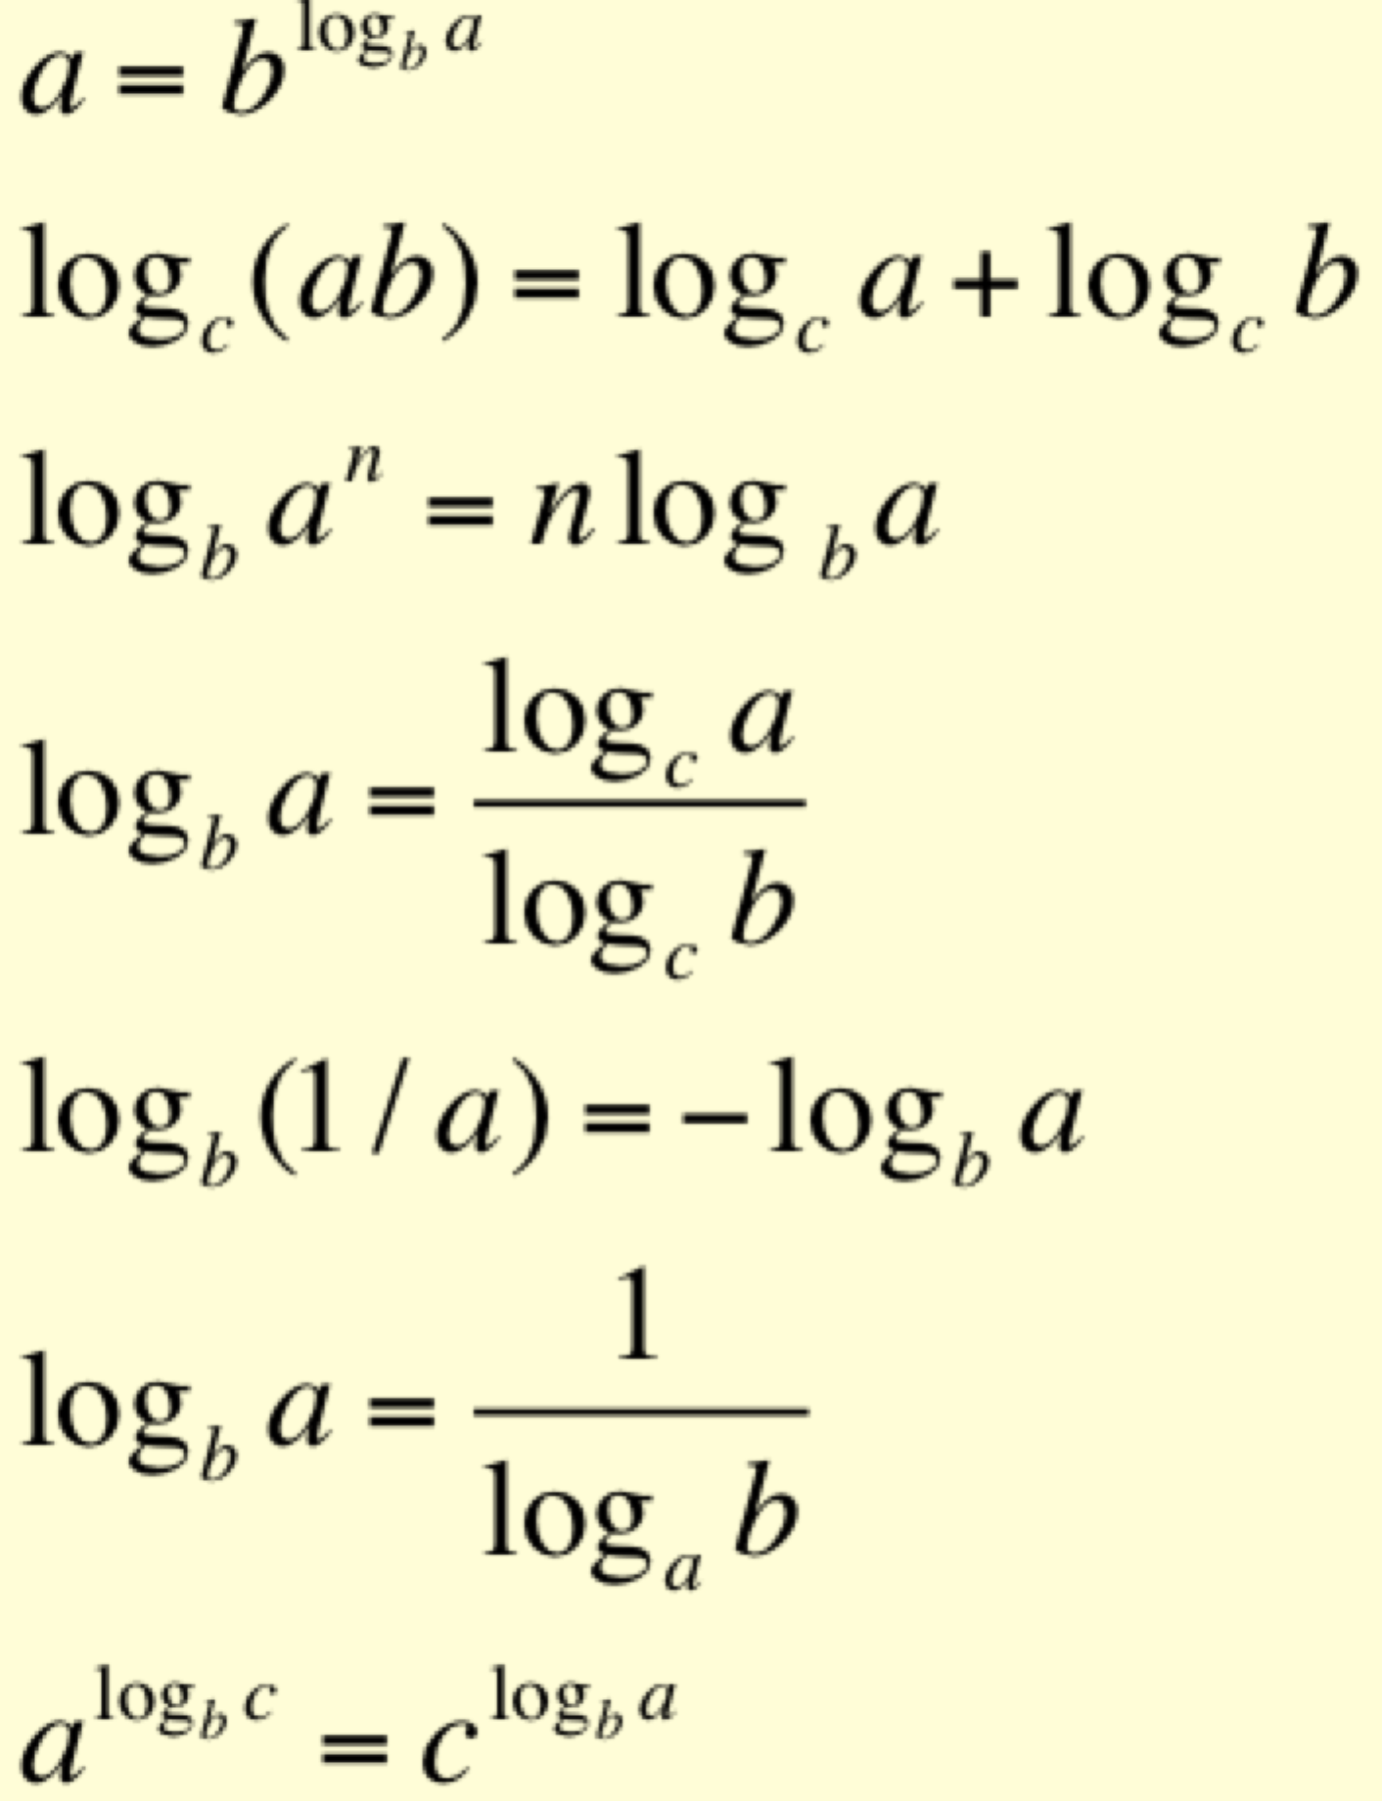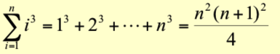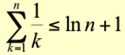
Termination: the loop terminates, when j=n+1. Then the invariant states: “A[1…n] consists of elements originally in A[1…n] but in sorted order.”
Maintenance: the inner while loop finds the position i with A[i] <= key, and shifts A[j-1], A[j-2], …, A[i+1] right by one position. Then key, formerly known as A[j], is placed in position i+1 so that A[i] <= A[i+1] < A[i+2].
A[1…j-1] sorted + A[j] -> A[1…j] sorted

Heap sort: Put all the elements into a binary tree, and then pull them out one by one?

Quick sort: (again recursive) You can have non-random and random. In non-random, you choose the last element to be the pivot, and then you organize everything into what’s less than and what’s greater than the pivot and then once you’ve compared everything you put the pivot right between those two groups. Then, you call again on the two groups, those greater and those less than the pivot. The loop invariants are that everything below is in one area, above is in another, and pivot is certain index.
Worst case for Quicksort is when the partition is T(n) = T(n-1) + T(0) + PartitionTime(N) = T(n-1) + c*n. = O(n^2).

Need to show this is O(n)
T(n) = T(n - 1) + O(1)

Plan to show by def
T(n) <= cn for all n >= n0

assume
T(n - 1) <= c(n - 1)

then
T(n) = T(n - 1) + O(1)
T(n) <= c(n - 1) + d
T(n) <= cn + d - c
T(n) <= cn for c >= d

Partition(A, p, r)
x, i := A[r], p – 1;
for j := p to r – 1 do
if A[j] ≤ x then
i := i + 1;
A[i] ↔ A[j]
fi
od;
A[i + 1] ↔ A[r];
return i + 1

Pr{candidate i is hired}
i is hired only if i is better than 1, 2,…,i-1.
By assumption, candidates arrive in random order
Candidates 1, 2, …, i arrive in random order.
Each of the i candidates has an equal chance of being the best so far.
Pr{candidate i is the best so far} = 1/i.
E[X_{i}] = 1/i. (By Lemma 5.1)

A[p..i] — All entries in this region are ≤ pivot.
A[i+1..j – 1] — All entries in this region are > pivot.
A[r] = pivot.

Fix 2: Median-of-three Quicksort.
Use median of three fixed elements (say, the first, middle, and last) as the pivot.
To get O(n²) behavior, we must continually be unlucky to see that two out of the three elements examined are among the largest or smallest of their sets
Initialization: j = 2, the invariant trivially holds because A[1] is a sorted array. √

for j=2 to length(A)
do key=A[j]
i=j-1
while i>0 and A[i]>key
do A[i+1]=A[i]
i--
A[i+1]:=key

Loop Invariant

Quicksort(A, p, r)
if p < r then
q := Partition(A, p, r);
Quicksort(A, p, q – 1);
Quicksort(A, q + 1, r)
fi
MergeSort (A, p, r) // sort A[p..r] by divide & conquer
- if p < r
- then q ← ⎣(p+r)/2⎦
- MergeSort (A, p, q)
- MergeSort (A, q+1, r)
- Merge (A, p, q, r) // merges A[p..q] with A[q+1..r]

Red black trees
- Every node is either red or black.
- The root is black.
- Every leaf (nil) is black.
- If a node is red, then both its children are black.
- For each node, all paths from the node to descendant leaves contain the same number of black nodes.
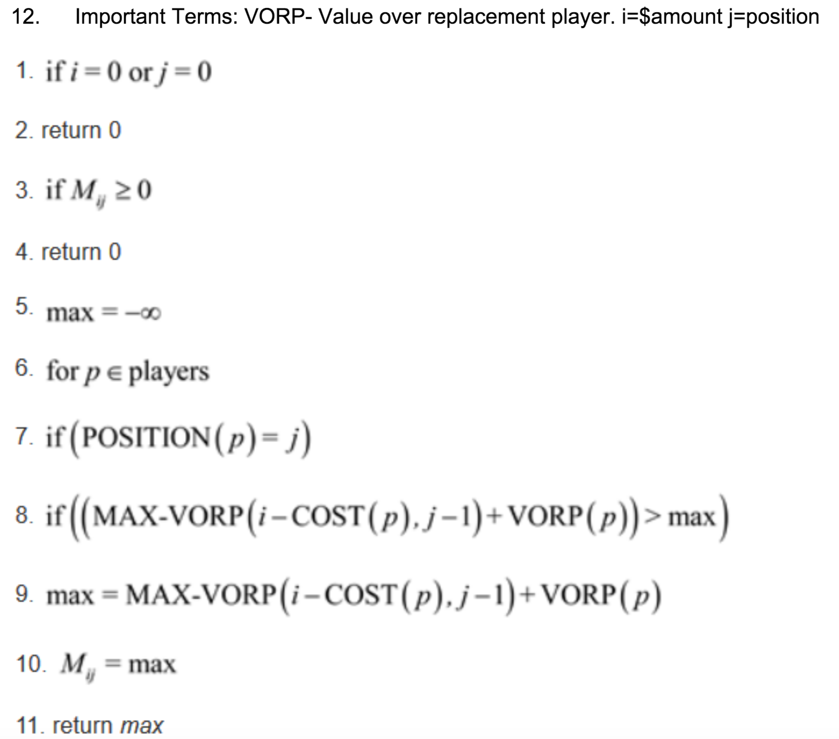
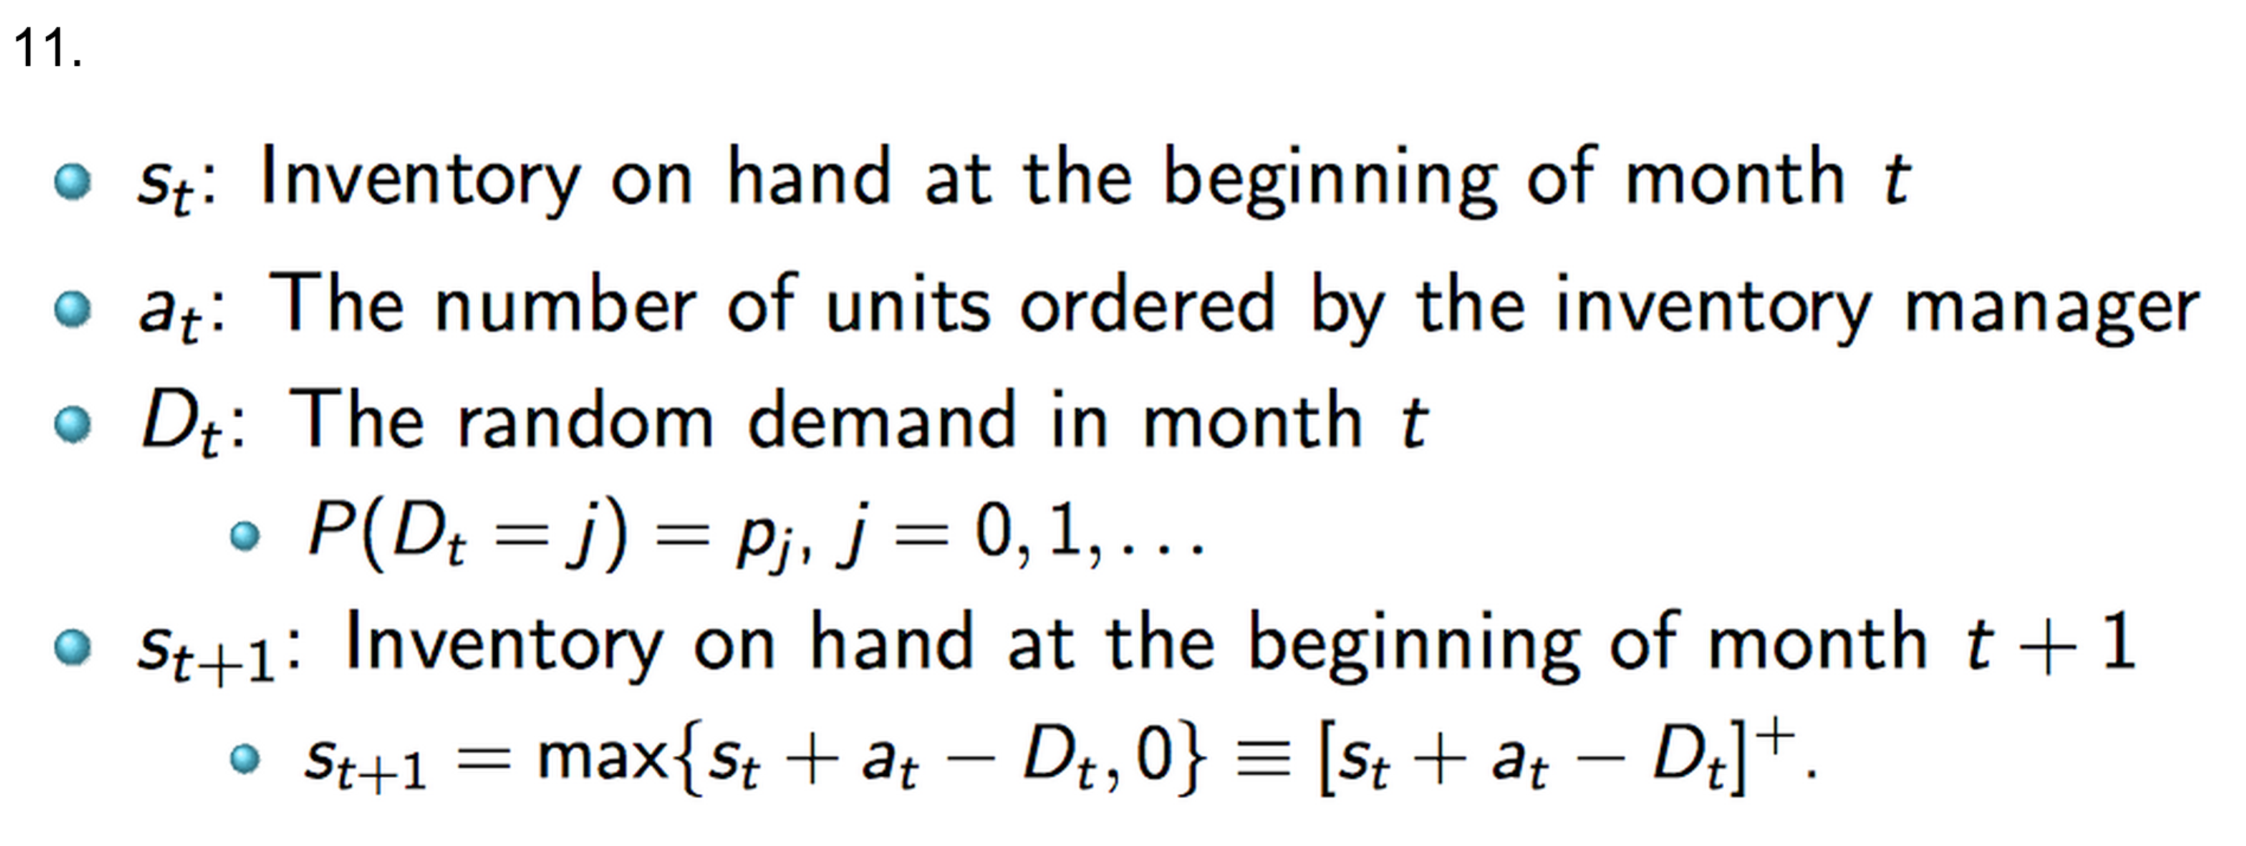
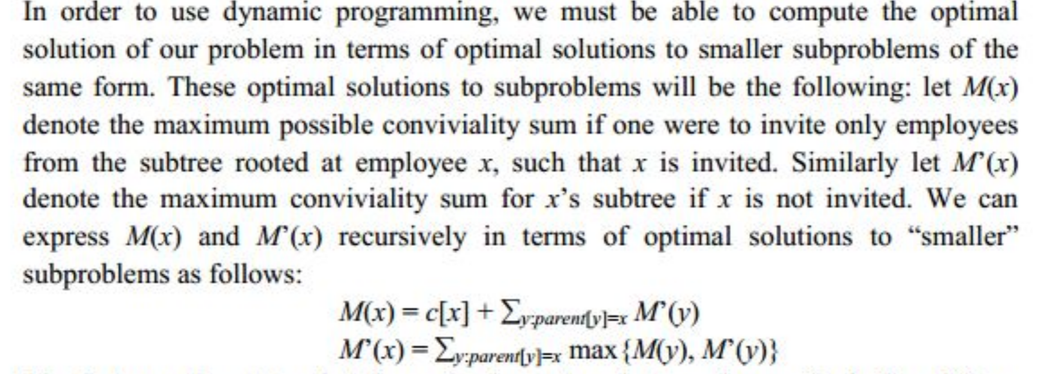
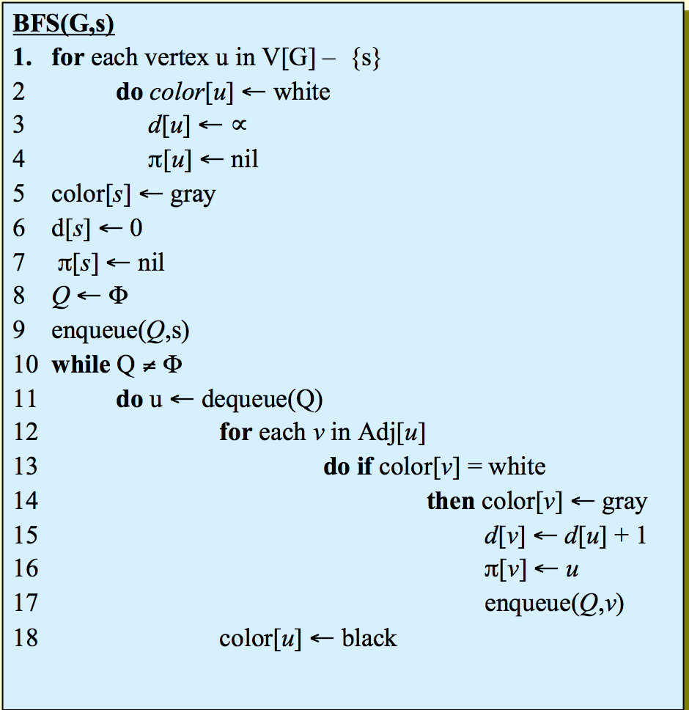
Image Compression by seam carving - basically, have every pixel get the minimum seam disruption value of the pixels below it, which is defined by the minimum of the pixels below that plus the seam disruption value of the current pixel. This is an O(3^n) problem.
seam(A[i,j]) = + d[i,j] + min(seam(A[i-1,j+1],A[i-1,j],A[i-1,j-1]))
seam(A[1,j]) = d[1,j]

8.

6.

- Sort all of the points by x-values (O nlgn). So, in a list of points, pi..j, for which each point is strictly left or right of the next in the list. |p1p2| is the distance between two points on the graph. b is the array of points, which is defined as follows:

- Longest simple path in a directed acyclic graph
Find a the longest simple path from s to t in a weighted, directed, acyclic graph G=(V,E).
(If we left out acyclic, would we still have optimal substructure?)
- Longest palindrome subsequence
Find the longest palindrome in a string X. A palindrome reads the same forward and backward.
- Bitonic Euclidean traveling salesperson
Given n positions of cities on the plane, find the shortest tour that visits all of them, under the restriction that you have go from right to left and then back again. (If we remove that restriction we lose optimal substructure)
- Printing neatly
- Edit distance
- Planning a company party
- Viterbi algorithm: recognize speech that can be generated from a directed graph with each edge labeled by a sound from a finite set of phonemes.
- Image compression by seam carving
- Breaking a string
- Planning an investment strategy
- Inventory planning
- Signing free-agent baseball players

Breath first:
Run-time: O(V+E)
Essentially, you start at some position and go uniformly out, in a layered fashion.
Invariant: Queue contains all (discovered) adjacent vertices in discovered/increasing distance order from source

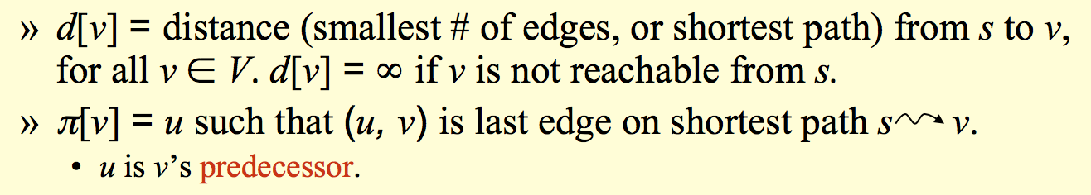

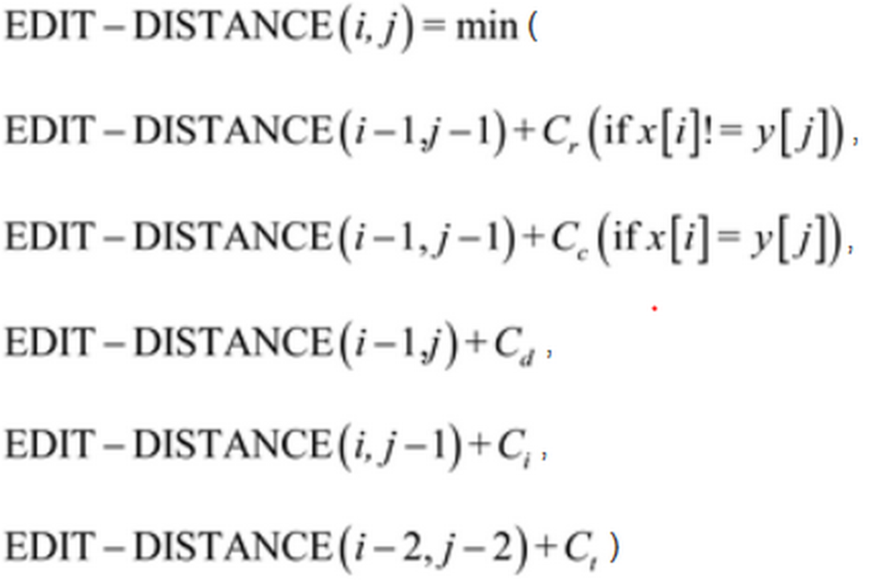
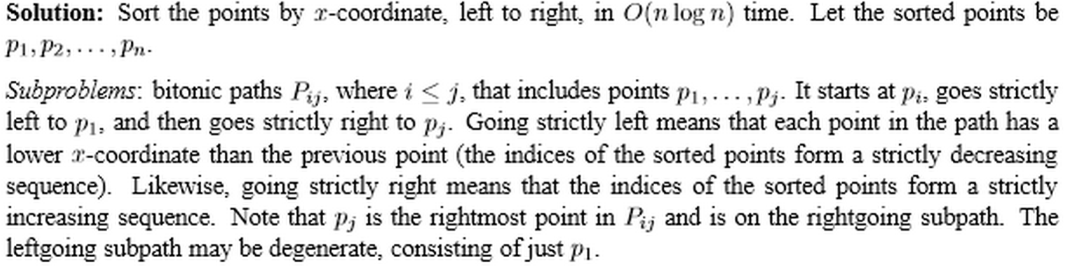
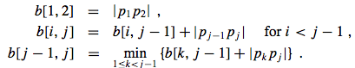
My answer: assuming that M is no smaller than the word in the input of largest length.
we wish to minimize the line cost of neatly printing the words in a paragraph. The line cost is when dealing with beginning word of line i, and ending word j where i<=j as such:
LC=(M-j-+i-k=i to j (length of word k))^3
wishing to minimize this, given the input, take subinputs. i.e given words 1...n, the subinputs used to find optimal solution of the whole by using previous optimal solutions of the subinputs are j=1...n so, go from 1...j where j goes from 1...n. This is quadratic.

If vertex is connected, there is a path between every pair of vertices. |E| \geq |V| -1.
If |E| = |V| -1, then it’s a tree.
A forest is a collection of trees.
Adjacency lists just stores a linked list of all vertices connected to a given vertex. So max size would be V^2.
Adjacency list requires O(V+E) storage for directed and undirected.
Adjacency is best for sparse, matrix is best for dense.

5.

Depth first:
Run-time: O(2V+E)
Invariant: Vertex’s discovered time is > that of all previously discovered vertices and finishing time> all finishing times of vertices adjacent.

4.

3.

